Administrator Login Sequence Diagram
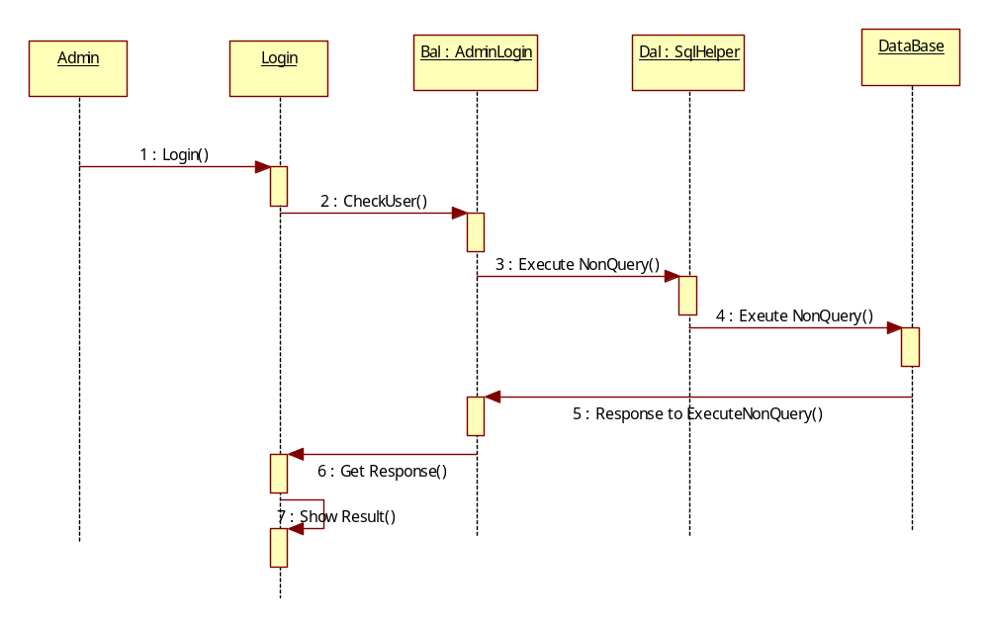

Administrator Add Country Sequence Diagram

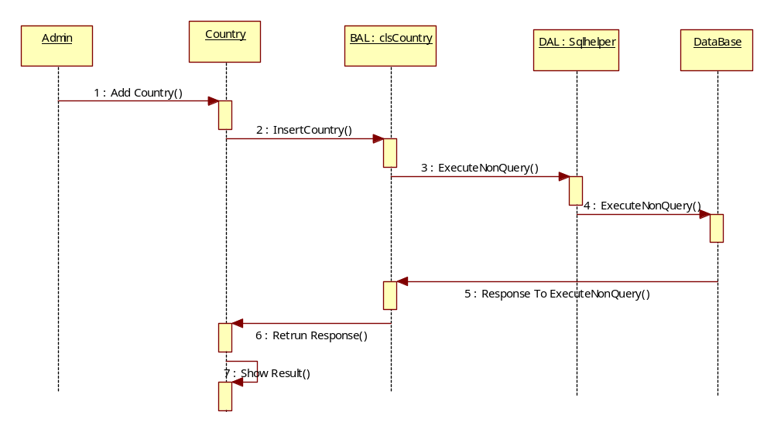
Admin Add Product Sequence Diagram
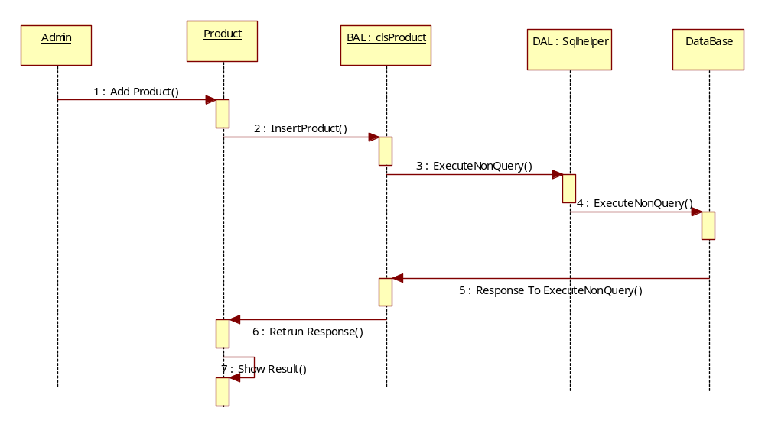

Admin Add Category Sequence Diagram
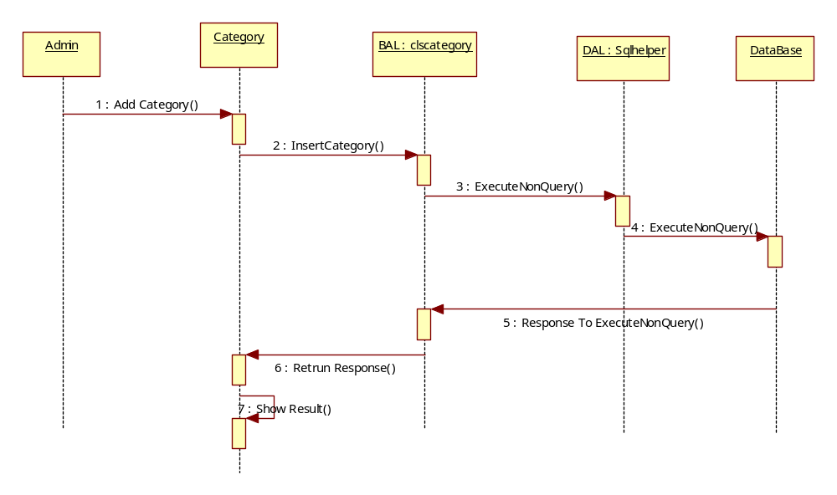

User Account Details Sequence Diagram
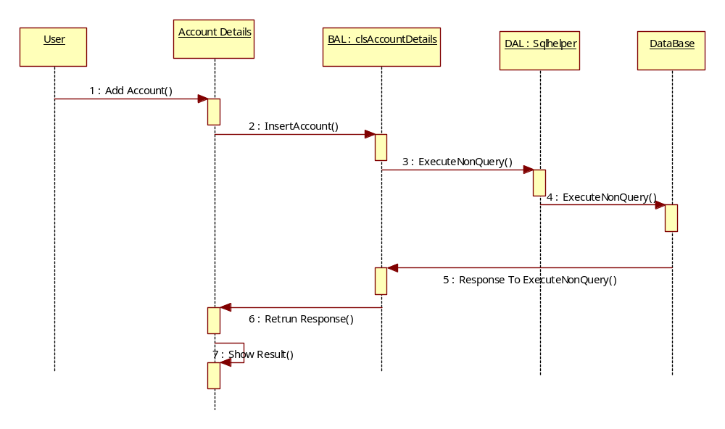

User Order Product Details Sequence Diagram
